Open Google Crome

1. Create/Register Account in APN Portal
   1. Open [APN Portal](https://partnercentral.awspartner.com/PartnerProfile).

Please use LTIMindtree email id ([FirstName.LastName@ltimindtree.com](mailto:FirstName.LastName@ltimindtree.com)) to create APN Account:

* Watch this video for step by step process to create account in APN Portal [Youtube Video for APN Account creation](https://www.youtube.com/watch?v=YWwdMN4J5w8&t=1s)
  1. Please ensure to give Consent to sharing your data using below steps:
* Login back with APN portal using LTI Mindtree Id
* Click My Profile (Top Right Hand Side)-> Click My AWS Certifications -> Click Edit -> Fill in the “AWS T&C Account Email” field with LTIMindtree email address ([FirstName.LastName@ltimindtree.com](mailto:FirstName.LastName@ltimindtree.com))
* Select **Yes** in filed name "I consent to share my AWS Certifications with " LTIMindtree" *"
* Click “Submit” at the top of the screen

1. Access Accreditations courses
   1. Login to [APN Portal](https://partnercentral.awspartner.com/PartnerProfile) using [FirstName.LastName@ltimindtree.com](mailto:FirstName.LastName@ltimindtree.com) and password used in step 1.1
   2. Once done then open Accreditations which can be accessed through the direct links below:
2. [AWS Partner: Sales Accreditation (Business)](https://explore.skillbuilder.aws/learn/course/internal/view/elearning/13258/aws-partner-sales-accreditation-business)
3. [AWS Partner: Cloud Economics Accreditation](https://explore.skillbuilder.aws/learn/course/internal/view/elearning/1099/aws-partner-cloud-economics)
4. [AWS Partner: Accreditation (Technical)](https://explore.skillbuilder.aws/learn/course/internal/view/elearning/1096/aws-technical-professional)
   1. To open the above 3 Accreditations, use Sign Options as “AWS Partner Network” Option and Click “Sign In”. (Marked in Yellow & Red in the screenshot below)

If you are not able to see AWS Partner Network & can see only AWS Bulider ID then click on more login options & then click AWS Partner Network

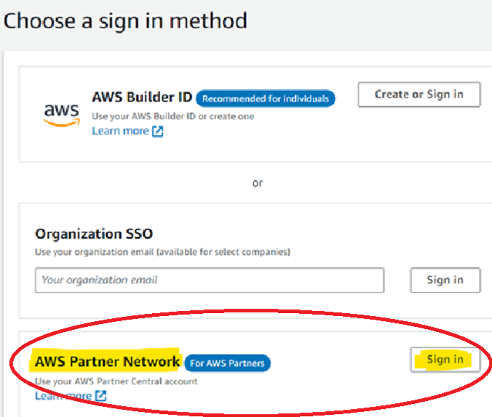

***Congratulations, You should now be able to access the Accreditations and kick start your***

***Learning Journey***

**Note**

* To get your badge, kindly do create a Credly account with business email ID. For more details on AWS Badges [Know more about AWS Credly Badges](https://www.credly.com/organizations/amazon-web-services/badges)
* If you are unable to play Accreditation videos on Skill Builder, check the ***Symantec WSS Agent*** and update to the latest version. Refresh the browser and try again.
* If you still face issue in accessing Accreditations, then please send email to [AWSome@ltimindtree.com](mailto:AWSome@ltimindtree.com)